МОДУЛЬНА КОНТРОЛЬНА РОБОТА № 1

Тема: Поведнікові шаблони

Мета: навчитися реалізовувати структурні шаблони проєктування, а саме: Ітератор, Команда, Стейт, Шаблоний метод та Відвідувач

Хід роботи:

Завдання:
Program.cs:
using System;
using Custom_HTML_Engine.Command;
using Custom_HTML_Engine.Elements;
using Custom_HTML_Engine.Iterator;
using Custom_HTML_Engine.State;
using Custom_HTML_Engine.Visitor;

namespace Custom_HTML_Engine
{
class Program
{
static void Main(string[] args)
{
var root = new Div();
root.SetText("Root div");

var p1 = new Paragraph();
p1.SetText("Paragraph 1");

var p2 = new Paragraph();
p2.SetText("Paragraph 2");

ICommand add1 = new AddElementCommand(root, p1);
ICommand add2 = new AddElementCommand(root, p2);

add1.Execute();
add2.Execute();

root.SetState(new LoadingState());
root.Render();
root.SetState(new RenderedState());

Console.WriteLine("\nTraversal:");
var iterator = new DepthFirstIterator(root);
while (iterator.HasNext())
{
var el = iterator.Next();
Console.WriteLine($"Element: {el.GetType().Name}");
}

Console.WriteLine("\nVisitor:");
var visitor = new CountVisitor();
root.Accept(visitor);
foreach (var child in root.GetChildren())
child.Accept(visitor);

Console.WriteLine($"Divs: {visitor.DivCount}, Paragraphs: {visitor.ParagraphCount}");
}
}
}

Command\AddElementCommand.cs:
using Custom_HTML_Engine.Elements;
using System;
using System.Collections.Generic;
using System.Linq;
using System.Text;
using System.Threading.Tasks;

namespace Custom_HTML_Engine.Command
{
public class AddElementCommand : ICommand
{
private HtmlElement parent, child;

public AddElementCommand(HtmlElement parent, HtmlElement child)
{
this.parent = parent;
this.child = child;
}

public void Execute() => parent.AddChild(child);
}
}
Command/ICommand.cs:
using System;
using System.Collections.Generic;
using System.Linq;
using System.Text;
using System.Threading.Tasks;

namespace Custom_HTML_Engine.Command
{
public interface ICommand
{
void Execute();
}
}

Elenents/Div.cs:
using System;
using Custom_HTML_Engine.Visitor;
using System.Collections.Generic;
using System.Linq;
using System.Text;
using System.Threading.Tasks;

namespace Custom_HTML_Engine.Elements
{
public class Div : HtmlElement
{
public override void Accept(IHtmlVisitor visitor) => visitor.VisitDiv(this);
}
}
Elenents/HtmlElement.cs:
using System;
using Custom_HTML_Engine.Visitor;
using Custom_HTML_Engine.State;
using System.Collections.Generic;
using System.Linq;
using System.Text;
using System.Threading.Tasks;

namespace Custom_HTML_Engine.Elements
{
public abstract class HtmlElement
{
protected List<HtmlElement> children = new();
protected string text;
protected IElementState state = new RenderedState();

public void Render()
{
OnCreated();
OnInserted();
OnStylesApplied();
OnClassListApplied();
OnTextRendered();
foreach (var child in children)
child.Render();
}

public virtual void AddChild(HtmlElement element) => children.Add(element);
public void SetText(string text) => this.text = text;

protected virtual void OnCreated() => Console.WriteLine($"[{GetType().Name}] OnCreated");
protected virtual void OnInserted() => Console.WriteLine($"[{GetType().Name}] OnInserted");
protected virtual void OnStylesApplied() => Console.WriteLine($"[{GetType().Name}] OnStylesApplied");
protected virtual void OnClassListApplied() => Console.WriteLine($"[{GetType().Name}] OnClassListApplied");
protected virtual void OnTextRendered() => Console.WriteLine($"[{GetType().Name}] OnTextRendered: {text}");

public abstract void Accept(IHtmlVisitor visitor);
public void SetState(IElementState newState)
{
state = newState;
state.Handle(this);
}

public List<HtmlElement> GetChildren() => children;
}
}
Elenents/Paragraph.cs:
using System;
using Custom_HTML_Engine.Visitor;
using System.Collections.Generic;
using System.Linq;
using System.Text;
using System.Threading.Tasks;

namespace Custom_HTML_Engine.Elements
{
public class Paragraph : HtmlElement
{
public override void Accept(IHtmlVisitor visitor) => visitor.VisitParagraph(this);
}
}

Iterator/DepthFirstIterator.cs:
using Custom_HTML_Engine.Elements;
using System;
using System.Collections.Generic;
using System.Linq;
using System.Text;
using System.Threading.Tasks;

namespace Custom_HTML_Engine.Iterator
{
public class DepthFirstIterator : IHtmlIterator
{
private Stack<HtmlElement> stack = new();

public DepthFirstIterator(HtmlElement root)
{
stack.Push(root);
}

public bool HasNext() => stack.Count > 0;

public HtmlElement Next()
{
var current = stack.Pop();
foreach (var child in current.GetChildren())
stack.Push(child);
return current;
}
}
}
Iterator/IHtmlIterator.cs:
using Custom_HTML_Engine.Elements;
using System;
using System.Collections.Generic;
using System.Linq;
using System.Text;
using System.Threading.Tasks;

namespace Custom_HTML_Engine.Iterator
{
public interface IHtmlIterator
{
bool HasNext();
HtmlElement Next();
}
}

State/IElementState.cs:
using Custom_HTML_Engine.Elements;
using System;
using System.Collections.Generic;
using System.Linq;
using System.Text;
using System.Threading.Tasks;

namespace Custom_HTML_Engine.State
{
public interface IElementState
{
void Handle(HtmlElement element);
}
}
State/LoadingState.cs:
using Custom_HTML_Engine.Elements;
using System;
using System.Collections.Generic;
using System.Linq;
using System.Text;
using System.Threading.Tasks;

namespace Custom_HTML_Engine.State
{
public class LoadingState : IElementState
{
public void Handle(HtmlElement element)
{
Console.WriteLine($"[{element.GetType().Name}] State: Loading");
}
}
}
State/RemovedState.cs:
using Custom_HTML_Engine.Elements;
using System;
using System.Collections.Generic;
using System.Linq;
using System.Text;
using System.Threading.Tasks;

namespace Custom_HTML_Engine.State
{
public class RemovedState : IElementState
{
public void Handle(HtmlElement element)
{
Console.WriteLine($"[{element.GetType().Name}] State: Removed");
}
}
}
State/RenderedState.cs:
using Custom_HTML_Engine.Elements;
using System;
using System.Collections.Generic;
using System.Linq;
using System.Text;
using System.Threading.Tasks;

namespace Custom_HTML_Engine.State
{
public class RenderedState : IElementState
{
public void Handle(HtmlElement element)
{
Console.WriteLine($"[{element.GetType().Name}] State: Rendered");
}
}
}

Visitor/CountVisitor.cs:
using Custom_HTML_Engine.Elements;
using System;
using System.Collections.Generic;
using System.Linq;
using System.Text;
using System.Threading.Tasks;

namespace Custom_HTML_Engine.Visitor
{
public class CountVisitor : IHtmlVisitor
{
public int DivCount = 0;
public int ParagraphCount = 0;

public void VisitDiv(Div div) => DivCount++;
public void VisitParagraph(Paragraph p) => ParagraphCount++;
}
}
Visitor/IHtmlVisitor.cs:
using Custom_HTML_Engine.Elements;
using System;
using System.Collections.Generic;
using System.Linq;
using System.Text;
using System.Threading.Tasks;

namespace Custom_HTML_Engine.Visitor
{
public interface IHtmlVisitor
{
void VisitDiv(Div div);
void VisitParagraph(Paragraph p);
}
}
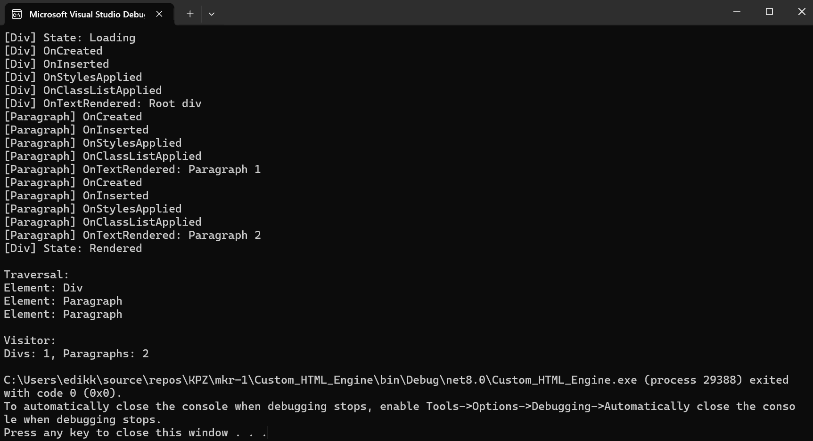
Рис. 1 Результат виконання завдання

Висновок: я навчився реалізовувати структурні шаблони проєктування, а саме: Ітератор, Команда, Стейт, Шаблоний метод та Відвідувач

